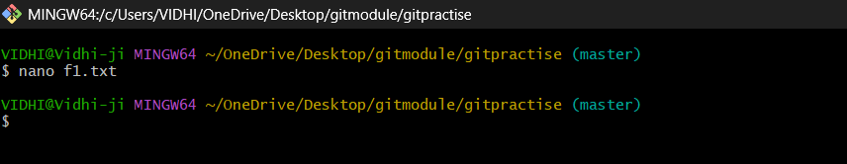

CREATE A LOCAL REPOSITORY BY GIT INIT(hidden)

SHOW HIDDEN FILES BY ls-a

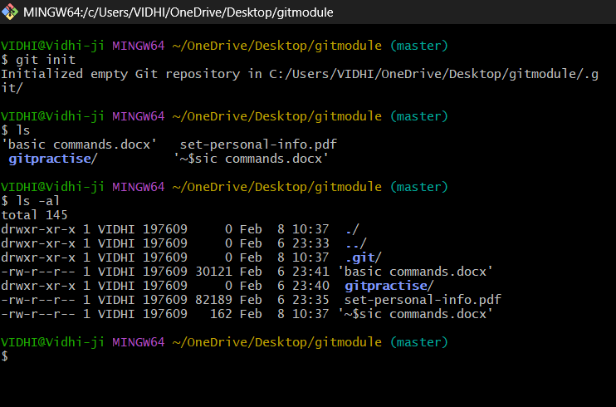

GIT STATUS

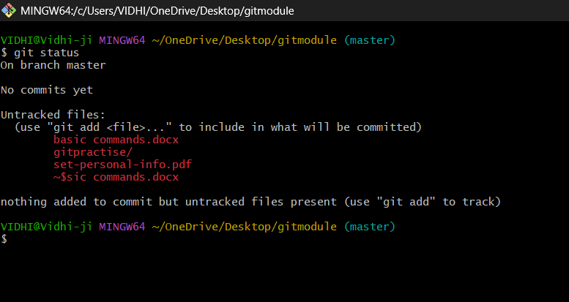

Git add – git gets aware of the file moves it to staging area

Git commit

Git log to check all the commits

